HHS WHRSC HR BizFlow System

Deployment

Document Control Information

Document Information

|  |  |
| --- | --- |
| Document Identification | HHS WHRSC BizFlow HR System Deployment.docx |
| Document Name | Deployment |
| Project Name | HHS WHRSC BizFlow HR System |
| Client | WHRSC |
| Document Author | Yung Oh |
| Document Version | 1.0.0 |
| Document Status | Draft |
| Date Released | 31-May-2018 |
| Business Specifications Requirement Document ID |  |
| Functional Specification ID |  |

Document Edit History

| Version | Date | Additions/Modifications | Prepared/Revised by |
| --- | --- | --- | --- |
| 1.0.1 | 06-June-2018 |  | Youngjin Oh |
| 1.0.2 | 20-June-2018 |  | Youngjin Oh |
| 1.0.3 | 09-July-2018 |  | Daehwa Kwak |

Document Review/Approval History

| Date | Name | Organization/Title | Comments |
| --- | --- | --- | --- |
|  |  |  |  |
|  |  |  |  |
|  |  |  |  |
|  |  |  |  |
|  |  |  |  |

Distribution of Final Document

The following people are designated recipients of the final version of this document:

| Name | Organization/Title |
| --- | --- |
| <Name> | <Organization/Title> |
|  |  |

Table of Contents

1. Introduction 4

2. Required system version information 5

3. Development directory structure 6

3.1 database Directory contents 6

3.2 deploy directory contents 6

3.3 process directory contents 7

3.4 report directory contents 7

3.5 wm-project directory contents 7

3.6 wm-runtime directory contents 8

4. Methods of deployment file delivery 9

4.1 Development repository in GitHub 9

5. Deployment Steps 10

5.1 Database Deployment 10

5.1.1 Create database schema and user 10

5.1.2 Grant permission required for program object creation 10

5.1.3 Create objects for business data model 10

5.1.4 Grant permission to the business data mode objects created 11

5.1.5 Create core table and program objects 11

5.1.6 Grant permission to the core table and program objects created 11

5.1.7 Insert seed data (a.k.a. day-zero data) 11

5.1.8 Create reminder email program objects 12

5.1.9 Grant permission to reminder email objects created 12

5.2 BIX deployment 12

5.3 Report Deployment 22

5.4 UI Module Packaging 24

5.4.1 Pre-requisite on DEV Server 24

5.4.2 Packaging Steps 24

5.5 Web Application (UI Module) Deployment 25

5.6 Configuration 27

BizFlow Server Configuration files. 27

5.6.1 server.ini Configuration 27

5.6.2 Web Server Configuration files. 27

5.6.3 BizFlow Web Portal Configuration 30

5.6.4 BizFlow Global Variable Configuration 31

5.6.5 Internet Explore Configuration 32

6. Event Response Adaptor (ERA) 36

# Introduction

This document describes how to deploy the HHS WHRSC BizFlow HR system. It is assumed that there are 3 environments, DEV, QA, and PROD. The instruction for deployment for each environment will be the same except for configuration. Configuration should be done specifically for each target environment.

# Required system version information

1. BizFlow: BizFlow Server version 12.4
2. Database: Oracle 12c
3. Web Server: Tomcat 7
4. Java: JDK 7

# Development directory structure

The following directory capture will be delivered as part of the release of the system.

WHRSC-BizFlow/database/

WHRSC-BizFlow/deploy/

WHRSC-BizFlow/process/

WHRSC-BizFlow/report/

WHRSC-BizFlow/ui/

WHRSC-BizFlow/ui/wm-project/

WHRSC-BizFlow/webapps/bizflow

## 3.1 database Directory contents

This directory contains database scripts (.sql files) to create database schema, users, and other objects, which includes the definition for tables, stored procedures, functions, triggers, sequence.

The DBA will execute the database scripts in Oracle database client (e.g. SQLPlus, SQL Developer, etc.) in the designated order (as part of the filename) so that the database for the system can be created.

Script file example:

WHRSC_HR_DB_01_create_schema.sql

WHRSC_HR_DB_02_grant_permission_bizflow.sql

WHRSC_HR_DB_03_create_model_objects.sql

WHRSC_HR_DB_04_grant_permission_model.sql

WHRSC_HR_DB_05_create_core_table.sql

WHRSC_HR_DB_06_create_core_program.sql

WHRSC_HR_DB_07_grant_permission_core.sql

WHRSC_HR_DB_08_1_insert_seed_data_OCCUPATIONAL_SERIES.sql

WHRSC_HR_DB_08_2_insert_seed_data_TYPE_VALUES.sql

WHRSC_HR_DB_08_3_insert_seed_data_RDR_APPROVAL.sql

WHRSC_HR_DB_09_reminder_program.sql

WHRSC_HR_DB_10_reminder_program_permission.sql

## 3.2 deploy directory contents

This directory contains script to capture web runtime files, deployment scripts, etc.

It is assumed Apache ANT is available to run the runtime capture script (build.xml).

The deployment script for UI module is for Linux server environment where shell program is available.

For example:

build.xml

## 3.3 process directory contents

This directory contains BizFlow Import Export file (.bix files), which contains the process definition, the application definition, user group definition, BizCove and menu design.

The system administrator will use BizFlow Process Studio in order to import the .bix file to a designated BizFlow Server environment.

BIX file example:

whrsc.bix

## 3.4 report directory contents

This directory contains BizFlow Advanced Reporting Export file (.zip file), which contains data source, report domain definition, input control definition, and report definition.

The system administrator will use command line tool to import the report export (.zip) file to the designated BizFlow Advanced Reporting Server environment.

Report export file example:

whrscreport.zip

## 3.5 wm-project directory contents

This directory contains WebMaker project export files (.zip files), which is form design source code.

The system administrator will use WebMaker Design Studio in order to import each of the project export files, generate runtime files, then, deploy them to the designated environments. As an alternative, wm-runtime directory contains the same generated web application files, which is ready to be deployed without going through WebMaker Design Studio.

WebMaker project export file example:

determine_staffing_export.zip

rdr_programapproval_export.zip

rdr_uploadassignment_export.zip

whrsc_appointment_appointment_export.zip

whrsc_appointment_approval_export.zip

whrsc_appointment_finalprocessing_export.zip

whrsc_appointment_main_export.zip

whrsc_appointment_orientation_export.zip

whrsc_appointment_payinformation_export.zip

whrsc_appointment_transaction_export.zip

whrsc_AUT_export.zip

whrsc_common_export.zip

whrsc_recruitment_applicant_export.zip

whrsc_recruitment_certificate_export.zip

whrsc_recruitment_main_export.zip

whrsc_recruitment_prerecruitment_export.zip

whrsc_recruitment_transaction_export.zip

whrsc_recruitment_vacancy_export.zip

## 3.6 wm-runtime directory contents

This directory contains WebMaker runtime directories and files, which are generated from WebMaker Design Studio after importing respective project export files.

The system administrator will simply copy all of the runtime files to the designated web server (i.e. Tomcat) directory of the target environment. Then, the WebMaker application configuration files (morphyc.xml file), which should be tailored for the target environment will be copied to the designated directories.

/webapps/bizflowwebmaker/determinestaffing/

/webapps/bizflowwebmaker/rdr_programapproval/

/webapps/bizflowwebmaker/rdr_uploadassignment/

/webapps/bizflowwebmaker/whrsc_appointment/

/webapps/bizflowwebmaker/whrsc_AUT/

/webapps/bizflowwebmaker/whrsc_common/

/webapps/bizflowwebmaker/whrsc_recruitment/

...

/configuration/dev/tomcat/webapps/bizflowwebmaker/determinestaffing/doc/morphyc.xml

/configuration/dev/tomcat/webapps/bizflowwebmaker/rdr_programapproval/doc/morphyc.xml

/configuration/dev/tomcat/webapps/bizflowwebmaker/rdr_uploadassignment/doc/morphyc.xml

/configuration/dev/tomcat/webapps/bizflowwebmaker/whrsc_appointment/doc/morphyc.xml

/configuration/dev/tomcat/webapps/bizflowwebmaker/whrsc_AUT/doc/morphyc.xml

/configuration/dev/tomcat/webapps/bizflowwebmaker/whrsc_common/doc/morphyc.xml

/configuration/dev/tomcat/webapps/bizflowwebmaker/whrsc_recruitment/doc/morphyc.xml

...

The same set of configuration files for QA and PROD environments will be provided under the respective directories.

/configuration/qa/

/configuration/prod/

# Methods of deployment file delivery

The following methods of deployment file delivery may be considered.

* USB drive to HHS team
* Upload to a designated ftp/sftp site in HHS network by authorized Deloitte team
* Upload from HHS issued laptop by authorized Deloitte team
* Download from HHS GitHub site (https://github.com/HHS) by HHS personnel.

NOTE: The Confluence site will be discontinued as code repository in the near future. Therefore, it is strongly recommended to use GitHub going forward.

## 4.1 Development repository in GitHub

1. Log in to GitHub for HHS (https://github.com/HHS).
2. On the dashboard, select context dropdown to “HHS”.
3. On the Repositories pain, search for “BizFlow”, and select “HHS/WHRSC-BizFlow”.

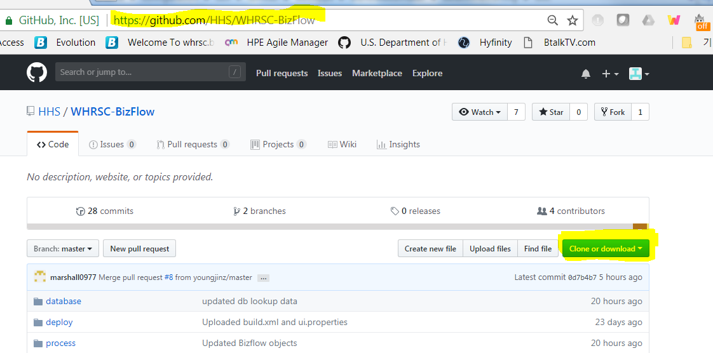

1. Verify the URL and repository name.
2. Click “Clone or download” button. If you intend to set up local git repository and continue to use it in the future, clone the repository using SSH or HTTPS option. If you want to download the entire repository for each build/deploy, select “Download ZIP” option.

# Deployment Steps

## 5.1 Database Deployment

A DBA should perform the following steps using Oracle database client.

### 5.1.1 Create database schema and user

Log in to the database system as Oracle system user, and execute the following script. Before executing the SQL script, you may want to edit the password for the database user (WHRSCADMIN, and HHS_WHRSC_HR) in the script. Make a note of the database user name and password for later configuration steps.

Also, make sure the target directory where the tablespace file will be generated is already created in the file system that the DBMS is installed.

For the first SQL script file, it is recommended to execute the statements within the SQL script file one by one manually and make sure that no critical error occurs. The reason is that the first script creates tablespace, datafile, user/schema, security role,etc., which are prone to error depending on the DBMS environment. If a critical error occurs (e.g. directory does not exist, disk full, etc.) you need to resolve those issues before moving to the next command. In general, you may safely ignore “object/table/view/symbol does not exist” type of error returned when executing DROP statements.

WHRSC_HR_DB_01_create_schema.sql

It will perform the following actions.

* Define database, specifying tablespace and database file location.
* Create database users and schemas.
* Create database roles.
* Grant permissions to the database users and roles.

### 5.1.2 Grant permission required for program object creation

Using the Oracle system user login, execute the following script. This is pre-requsite for certain functions and stored procedures defined later on, which need to access objects in BIZFLOW schema.

WHRSC_HR_DB_02_grant_permission_bizflow.sql

It will perform the following actions.

* Grant permissions for accessing BizFlow’s core database tables to the designated database user.

### 5.1.3 Create objects for business data model

Log in to the database system using the newly created database user account (id = HHS_WHRSC_HR), using the password that was set in the step 5.1.1. As the HHS_WHRSC_HR database user, execute the following script.

WHRSC_HR_DB_03_create_model_objects.sql

It will perform the following actions.

* Create tables for WHRSC business data storage.
* Create sequences, constraints, and triggers associated with the tables.
* Create stored procedures.

### 5.1.4 Grant permission to the business data mode objects created

Using the Oracle system user login, execute the following script.

WHRSC_HR_DB_04_grant_permission_model.sql

It will perform the following actions.

* Grant permissions for accessing the newly created database objects for business data model in the previous step to the designated database roles.

### 5.1.5 Create core table and program objects

Using the HHS_WHRSC_HR user login, execute the following script.

WHRSC_HR_DB_05_create_core_table.sql

It will perform the following actions.

* Create tables for generic use by program objects (functions and stored procedures).
* Create sequences, constraints, and triggers associated with the tables.

WHRSC_HR_DB_06_create_core_program.sql

It will perform the following actions.

* Create stored procedures.
* Create functions.

### 5.1.6 Grant permission to the core table and program objects created

Using the Oracle system user login, execute the following script.

WHRSC_HR_DB_07_grant_permission_core.sql

It will perform the following actions.

* Grant permissions for accessing the newly created database objects for program to the designated database roles.

### 5.1.7 Insert seed data (a.k.a. day-zero data)

Using the HHS_WHRSC_HR user login, execute the following scripts.

WHRSC_HR_DB_08_1_insert_seed_data_OCCUPATIONAL_SERIES.sql

WHRSC_HR_DB_08_2_insert_seed_data_TYPE_VALUES.sql

WHRSC_HR_DB_08_3_insert_seed_data_RDR_APPROVAL.sql

...

WHRSC_HR_DB_08_?_insert_seed_data_*.sql

It will perform the following actions.

* Insert the data into OCCUPATIONAL_SERIES table to be used as reference data.
* Insert the data into TYPE_VALUES table to be used as reference data for numerous dropdown field.
* Insert the data into RDR_APPROVAL table to be used as seed data for RDR Approval field.

### 5.1.8 Create reminder email program objects

Using the Oracle system user login, execute the following script.

WHRSC_HR_DB_09_reminder_program.sql

It will perform the following actions.

* Create stored procedures.
* Create functions.

### 5.1.9 Grant permission to reminder email objects created

Using the Oracle system user login, execute the following script.

WHRSC_HR_DB_10_reminder_program_permission.sql

It will perform the following actions.

* Grant permissions for accessing the newly created database objects for program to the designated database roles.

## 5.2 BIX deployment

Import BizFlow Process definitions and BizCoves

Pre-requisite

* BizFlow Server is installed and BizFlow Server is running.
* BizFlow Process Studio (BPS) is installed.
* BizFlow user with “General Administrator” and “Designer” license is created for migration.

In this instruction, a user login “import_user” is assumed to be set up with the necessary permission. In order to verify the BizFlow user with proper permission, log in to BizFlow Portal site as a system administrator, and check the Authentication configuration.

1. Log in to BizFlow Portal as a system administrator.
2. Click “ADMINISTRATION” tab on the top right corner.
3. Click Authentication on the administration page.
4. Search the user login to verify and click on the login ID found to open User Details wizard.
5. Click License tab and Authority Group tab in the wizard to verify the license assignment and Authority Group assignment.

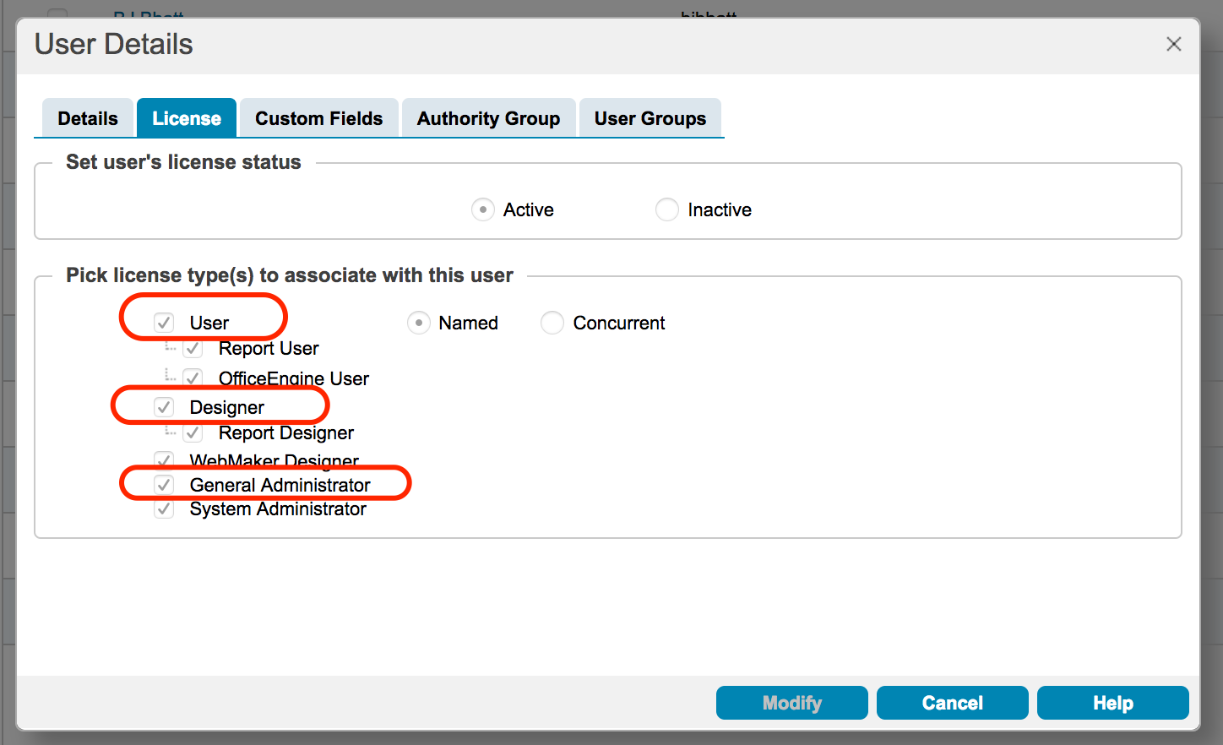

For Authority Group assignment option, it is recommended to use “Explicit”. Then, make sure explicitly select Designer and General Administrator Authority Group along with others.

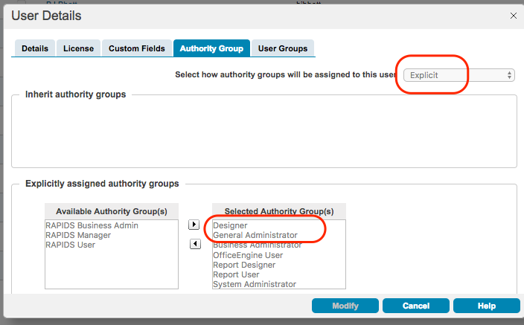

When all pre-requisite for BIX import are verified, begin the import steps.

1. Step1 – Register BizFlow server to BPS
   1. Launch BPS and click “BizFlow Server” icon.

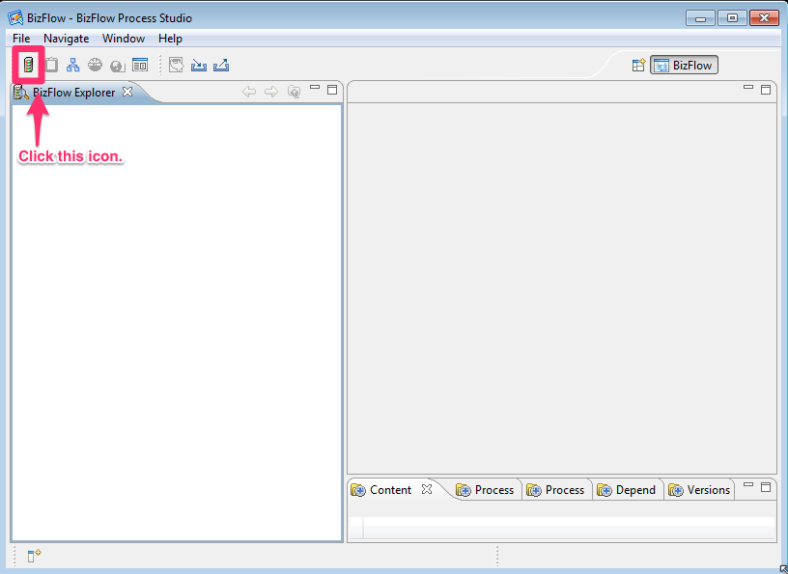

* 1. Provide Server information.

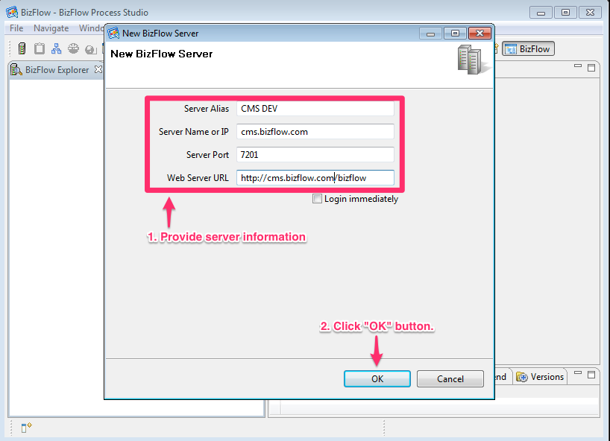

1. Step 2 - Log on to BizFlow Server.
2. This user needs to have “General Administrator” and “Designer” license.

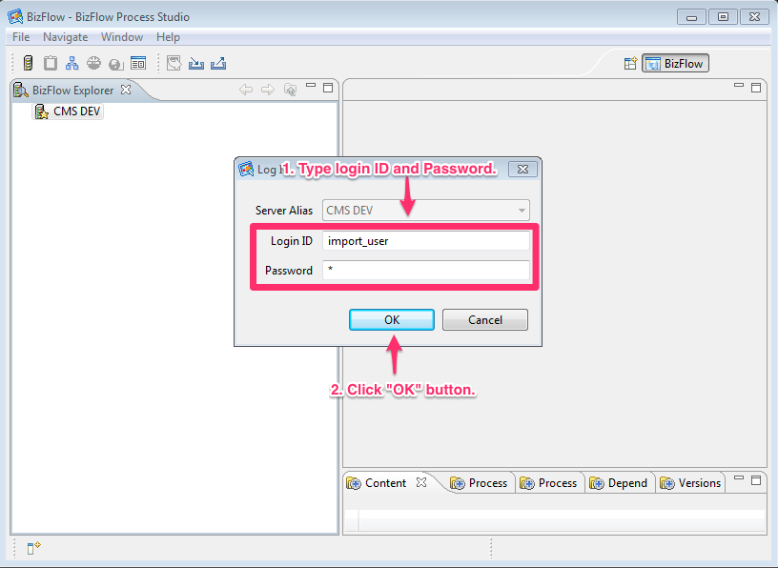

1. Step 3 - Click “Import” button.

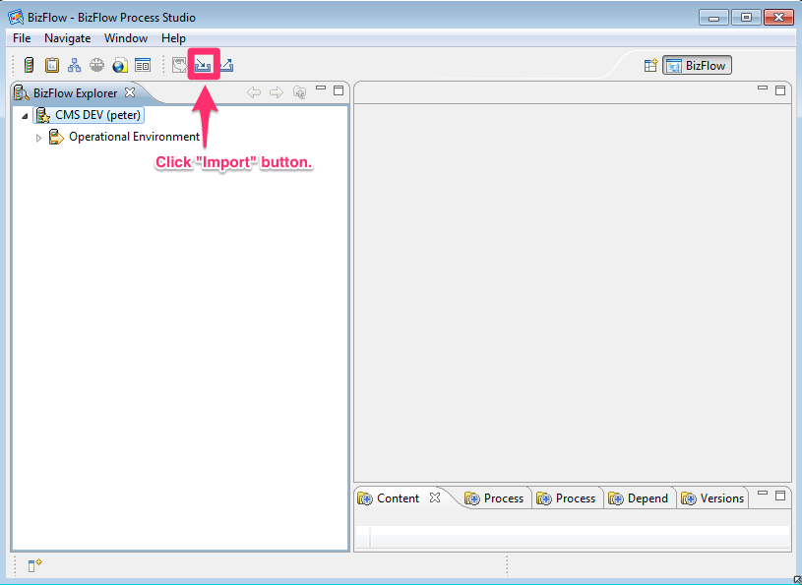

1. Step 4 - Select BizFlow BIX file.
2. Select proper server alias name in “Target Server” section.
3. Click “Browse” button and select “whrsc.bix” file.
4. Click “Next” button.

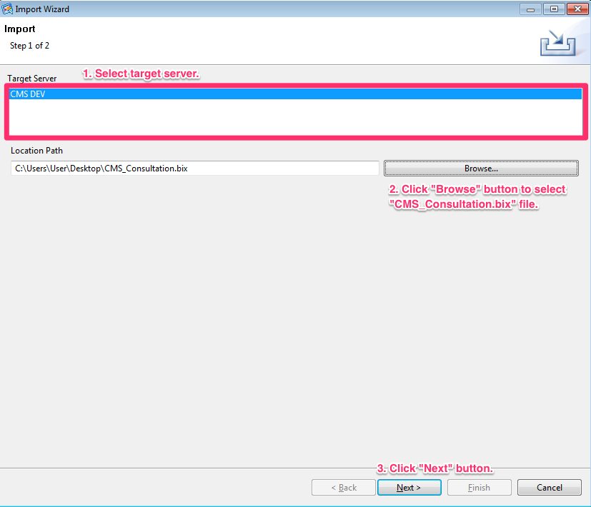

1. Step 5 - Click “+” icon to expand items and select “/Operational Environment/User Configuration/Authentication”.

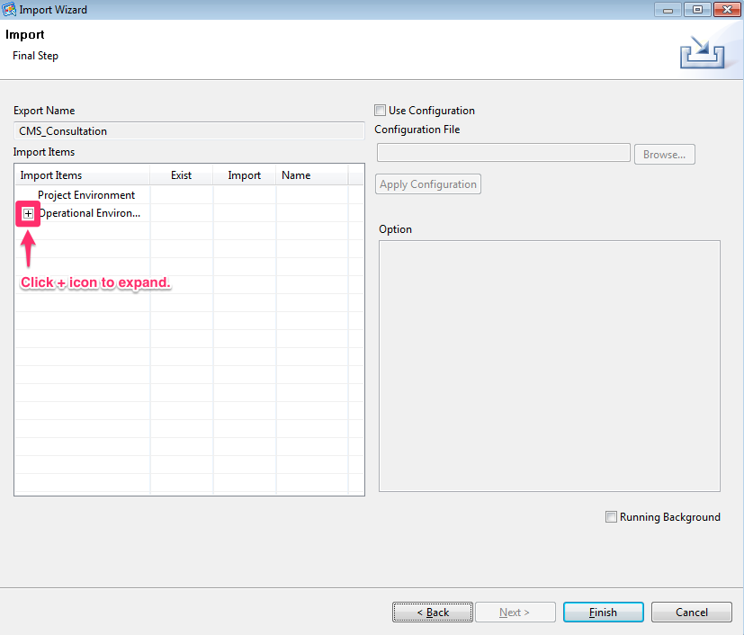

1. Step 6 - Uncheck “Create Users” option.
2. Import column should be set as “No”.

**Note**: The Create User option may be turned on in case user login accounts should be migrated, but in general, it should not be used. In the future deployment package, the test user entry may be excluded so that you may skip the Step 6.

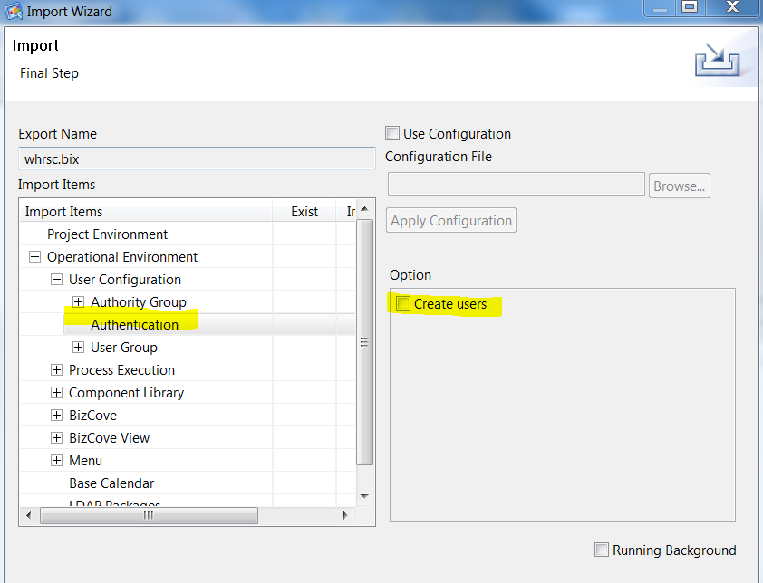

1. Step 7 - Uncheck “Link Users” option in “/Operational Environment/User Configuration/User Group”.

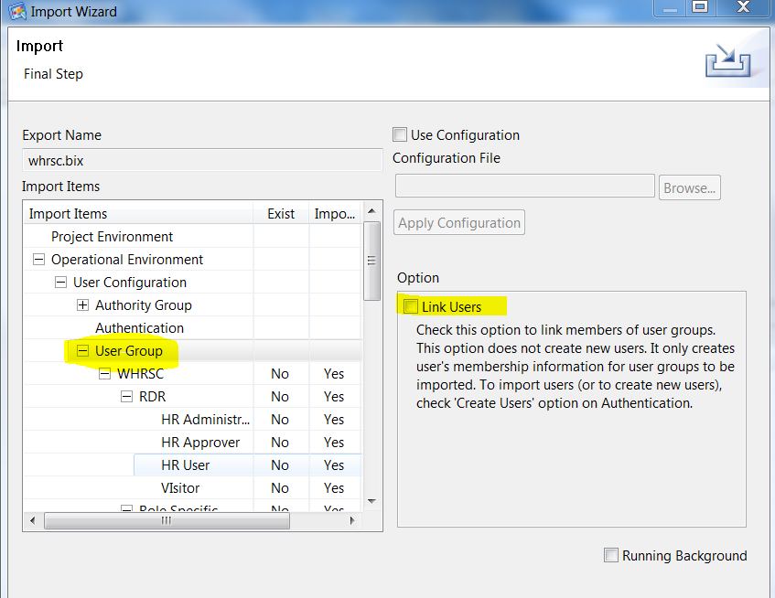

1. Step 8 - All user group under “/Operational Environment/User Configuration/User Group/WHRSC” should have “Yes” in “Import” column.

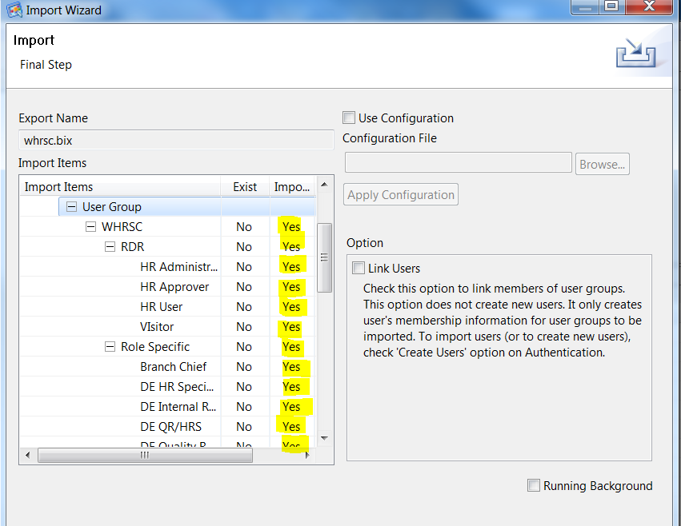

1. Step 9 - All Process Definitions under “/Operational Environment/Process Execution/Process Definition/Process Definitions/WHRSC” should have “Yes” in “Import” column.

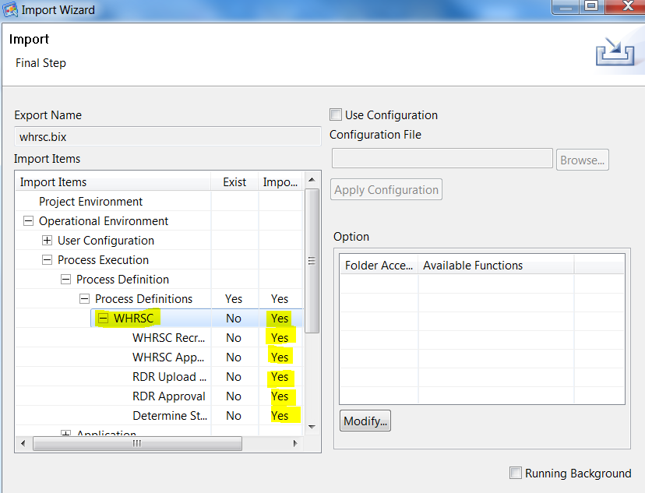

1. Step 10 - All Applications under “/Operational Environment/Application/Application/CMS” should have “Yes” in “Import” column.

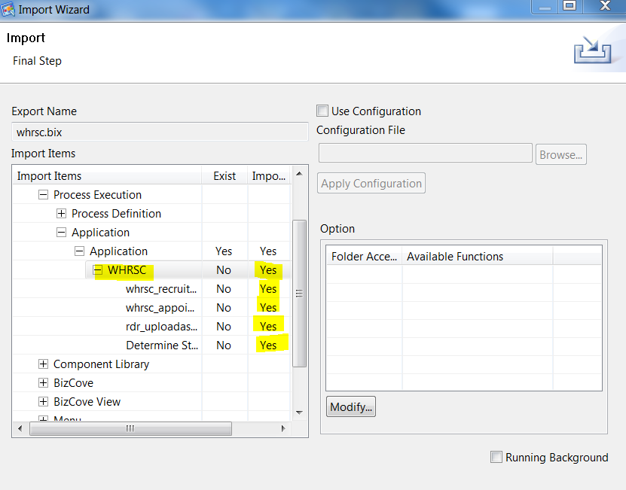

1. Step 11 – Set the value in “Import” column to “Yes” under “/Operational Environment/Component Library/Global Variable”.

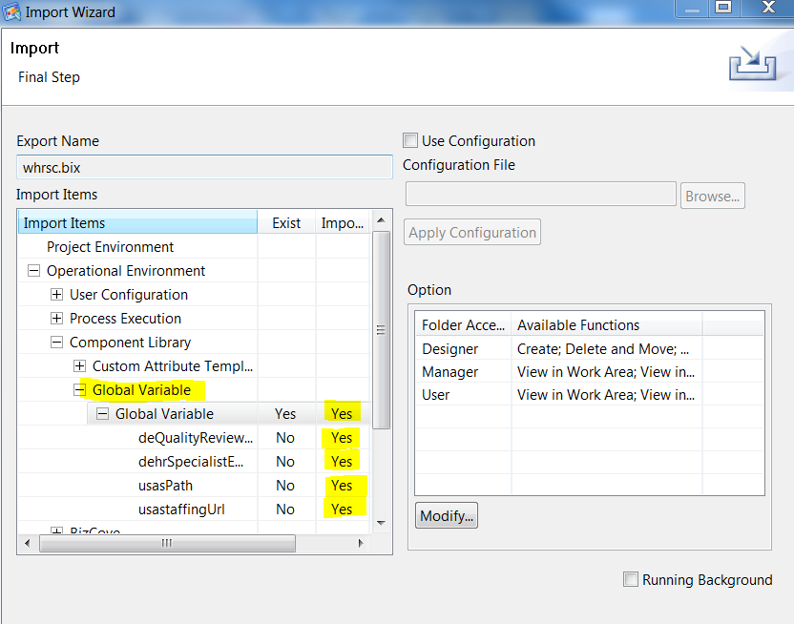

1. Step 12 - All BizCoves under “/Operational Environment/BizCove” should be set to “Yes” in Import column.

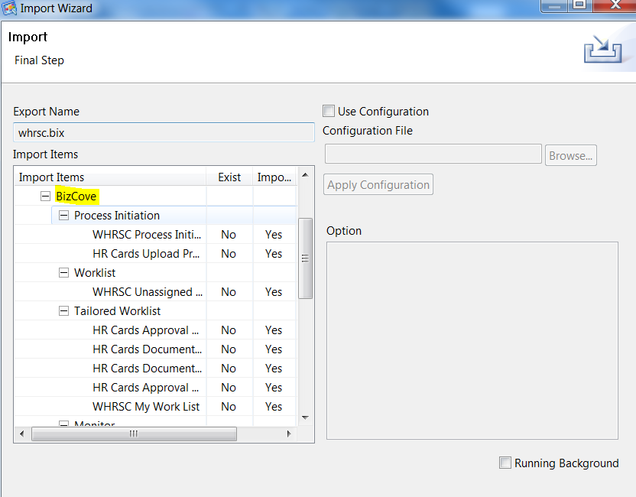

1. Step 13 - All BizCove View under “/Operational Environment/BizCove View” should have “Yes” in Import column.

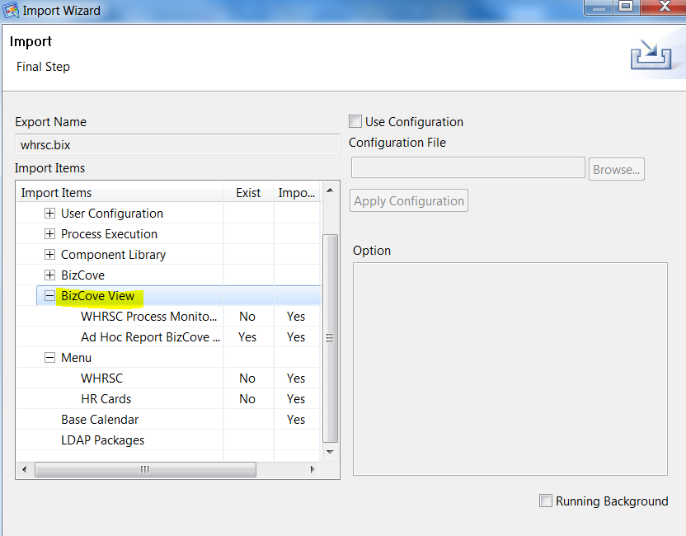

1. Step 14 - All Menu under “/Operational Environment/Menu” should have “Yes” in Import column.

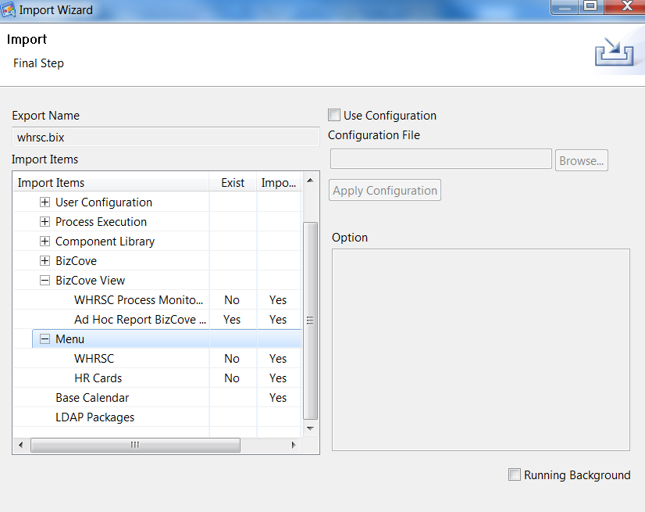

1. Step 15 - Click “Finish” button.

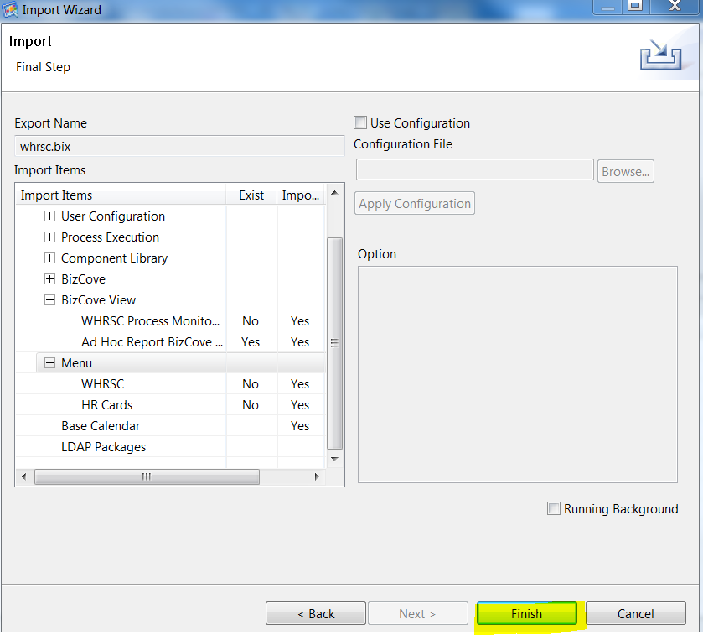

1. Step 16 - Click “OK” button and check log files.

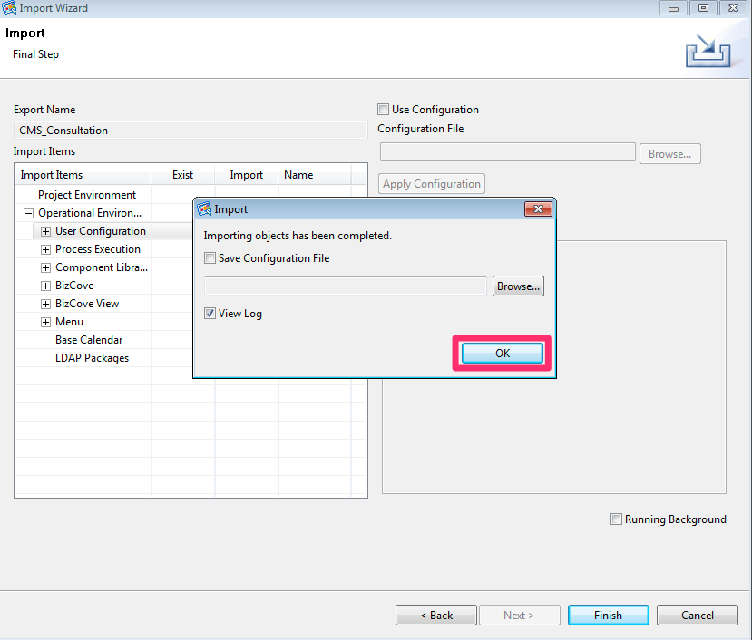

1. Repeat Step 1 through Step 16 per each environments.

## 5.3 Report Deployment

It is assumed that BizFlow Advanced Reporting (BAR) is installed on the server. In order to deploy report files to the reporting server, we need to install BAR Deployment Tool. Normally, BAR Deployment Tool is installed as part of the BAR server component on the server machine, especially Windows based server environments. However, the BAR for Linux has known issues at the moment. As a workaround, BAR Deployment Tool needs to be installed on a Windows machine that has network connection to the BAR server machine, and the user will execute the deployment tool in the Windows machine’s command line.

1. On the designated Windows machine, copy the BAR installation file (BizFlow_Advanced_Reporting_12.4.zip) and extract it in a temporary directory.
2. From the extracted directory, copy **BizFlowReporting** directory and its contents to a designated directory which the user has full access to.

For example:

C:\Users\john.doe\BAR\BizFlowReporting\

1. Open js.jdbc.properties file in a text editor, and update the following database connection information entries to point to the target environment’s BAR database.

For example:

C:\Users\john.doe\BAR\BizFlowReporting\buildomatic\build_conf\default\js.jdbc.properties

Make sure the properties are set as the following, with the appropriate values for the highlighted portion per each target environment.

**WARNING**: Before running any import or export command, make sure the connection information in the file is correct for the target environment. Failing to verifying the correct database connection information may result in overwriting report definition and dependent report constructe. Such failure may cause error or put the report structure in inconsistent state.

**metadata.hibernate.dialect**=com.jaspersoft.ji.hibernate.dialect.OracleJICustomDialect

**metadata.jdbc.driverClassName**=oracle.jdbc.driver.OracleDriver

**metadata.jdbc.url**=jdbc:oracle:thin:@dbhost:1521:sid

**metadata.jdbc.username**=bizflowreport

**metadata.jdbc.password**=*password_of_bizflowreport_db_login*

**propsToEncrypt**=metadata.jdbc.password

**encrypt**=false

The database connection information (DB server name, port number, and SID/Service Name, password) of BIZFLOWREPORT schema for each environment should be acquired from DBA team.

1. Open a command line, and change directory to the BAR build directory (buildomatic).

For example:

cd C:\Users\john.doe\BAR\BizFlowReporting\buildomatic

1. For the first time report import, export the current report data source information as a backup. You will need to use this each time report is imported. Create the data source export for each of the target environment.

For each environment, make JDBC connection info for the target database in the js.jdbc.properties file, and run the export command. Repeat the setting JDBC information and export command for each target environment.

js-export.bat --output-zip hhsreport_datasource_dev.zip --uris /organizations/organization_1/datasources/BizFlow_Data_Source

js-export.bat --output-zip hhsreport_datasource_qa.zip --uris /organizations/organization_1/datasources/BizFlow_Data_Source

js-export.bat --output-zip hhsreport_datasource_prd.zip --uris /organizations/organization_1/datasources/BizFlow_Data_Source

Once the data source back up is created, we can re-use this in the future and do not need to back up data source each time unless there is data source connection information change

1. Copy report export file in the buildomatic directory.

For example:

copy *whrscreport.zip* C:\Users\john.doe\BAR\BizFlowReporting\buildomatic\

1. In the buildomatic directory, execute import command to import the report to BAR server for the target environment.

For example:

js-import --update --skip-user-update --input-zip *whrscreport.zip*

**Note**: The report export zip file contains the data source information of the database for the report development environment from which the export file is generated. By importing the export zip file, the database connection information of the target BAR server is overwritten. Therefore, we will need to restore the data source information of the target environment using the backup file in the next step.

1. In the buildomatic directory, execute import command to import the data source backup file so that the correct data source connection information is restored for the target environment.

For example:

js-import --update --skip-user-update --input-zip *hhsreport_datasource_dev.zip*

## 5.4 UI Module Packaging

UI modules are captured from DEV environment's web application directory, using ANT build file.

The ANT build file will package the UI modules in a zip file. Especially for WebMaker runtime files, the script will capture configuration files separately per environment, which will be deployed to the target environment appropriately by the deployment script later on. The script also appends timestamp to the JavaScript and CSS file references in the web application files so that the web browser cache is forced to be refreshed at the first time loading after the new deployment.

### 5.4.1 Pre-requisite on DEV Server

* JDK/JRE 1.7
* Apache Ant 1.9.x
* Administrator (or sudo) access to DEV server machine
* UI modules are deployed and tested in DEV server, and ready for promotion to higher environments (e.g. QA and PROD)
  + WebMaker form runtime files
  + BizFlow solution files

### 5.4.2 Packaging Steps

1. Login to DEV server machine with an administrator (or sudo) account.
2. In the command line prompt, create a work directory where files will be generated, and change directory to it.

For example:

mkdir -p work/deploy

cd work/deploy

1. Copy UI packaging script to the deployment directory.

* From (source repository):

deploy/build.xml

* To (target environment):

*<DEV_server_dir>*/work/deploy/

1. Using a text editor, modify the following property value in the build.xml file for tomcat web application directory setting. Specify the full path to the tomcat directory.

<property name="**webserver.dir**" value="*full_path_to_tomcat_directory*" />

1. In the command line prompt, run ANT. The following will execute the default target, which will generate a zip file.

ant

1. Capture the generated zip file. The packaging script will create the intermediate directories and generate the UI runtime zip file with timestamp suffix.

For example:

*<DEV_server_dir>*/work/deploy/deployment/ui/runtime_*20180201_132525*.zip

## 5.5 Web Application (UI Module) Deployment

UI modules are deployed to the higher environments (e.g. QA, PROD) using shell scripts.

The deployment script will stop tomcat service, copy runtime files to tomcat web application directory, and start tomcat service.

1. Login to higher environment server machine with an administrator (or sudo) account.
2. In the command line prompt, create a work directory where the deployment package file will be placed, and change directory to it.

For example:

mkdir -p work/deploy/baseline/ui

cd work/deploy

1. Copy UI deployment script to the deployment directory.

* From (source repository):

deploy/deploy_ui_qa.sh

* To (target environment):

<DEV_server_dir>/work/deploy/

1. Using a text editor, modify the following property value in the deploy_ui_qa.sh for tomcat web application directory setting. Specify the full path to the tomcat directory.

**DIR_DEPLOY**=*<full_path_to_deploy_baseline_directory_above>*

**DIR_TOMCAT**=*<full_path_to_tomcat_directory>*

1. In the command line prompt, make the UI deployment script mode executable.

For example:

chomod 744 deploy_ui_qa.sh

1. Copy UI deployment package file to the UI deployment directory.

For example:

* From (source repository):

runtime_20180201_132525.zip

* To (target environment):

*<DEV_server_dir>*/work/deploy/baseline/ui

1. In the command line prompt, extract the UI runtime zip file. If there is previous extract of runtime files, remove it before fresh extract.

For example:

cd baseline/ui

rm -rf runtime

unzip runtime_*20180201_132525*.zip

1. In the command line prompt, change directory back to the deployment directory, and run the deployment script.

For example:

cd <DEV_server_dir>/work/deploy

./deploy_ui_qa.sh -nodebug

Note: The deployment script has "-nodebug" option for real deployment action. If you run the script without the option, it will try to test directory setting without actually deploying any file. This is a precautionary measure to prevent accidental overwriting of the target application files. In order to run the deployment script in "DEBUG" mode, i.e. without "-nodebug" option, a dummy script should be placed in the deployment directory. Make sure the dummy script mode is executable.

For example:

* From (source repository):

deploy/script1.sh

* To (target environment):

*<DEV_server_dir>*/work/deploy/

cd <DEV_server_dir>/work/deploy

chomod 744 script1.sh

./deploy_ui_qa.sh

## 5.6 Configuration

After deploying web application runtime files, we need to make changes to the configuration.

### BizFlow Server Configuration files.

### 5.6.1 server.ini Configuration

1. Log in to the machine where BizFlow Server is installed.
2. Open <BIZFLOW_SERVER_DIRECTORY>/bin/server.ini file in a text editor.
3. Find and set the following entry.

**DeadlineMailSender**=DoNotReply@hhs.gov

1. This change requires BizFlow Server service restart. Restart the services after all the other configuration steps are completed.

### 5.6.2 Web Server Configuration files.

#### 5.6.2.1 JNDI Configuration

1. Continue to use the system administrator login to the server machine that hosts the web server.
2. Launch a text editor (e.g., notepad) as an administrator, open the Tomcat context configuration file.

For example:

D:\Program Files\Apache Software Foundation\Tomcat7\conf\context.xml

1. Near the end of the context.xml file, enter the following content for JNDI configuration.

===============================================================================

<Context>

<!-- There may be some existing content. Make sure you enter the following within the "Context" element. -->

<Resource

name="jdbc/workflowdb"

auth="Container"

type="javax.sql.DataSource"

initialSize="2"

maxActive="200"

maxIdle="30"

maxWait="10000"

driverClassName="oracle.jdbc.OracleDriver"

**url**="jdbc:oracle:thin:@example.server.com:1521:orcl"

**username**="bizflow"

**password**="bizflow_database_password"

validationQuery="select 1 from dual"

defaultTransactionIsolation="READ_COMMITTED"

defaultAutoCommit="true"

/>

</Context>

The only attribute values need updates are the highlighted ones above.

* **url**: The value should be the standard JDBC connection URL to the database server, which holds the BizFlow core database as well as the HHS CMS BizFlow HR database.
* **username**: The value should be the database username used as part of BizFlow Server installation, i.e., the schema name for BizFlow core database. It is assumed “bizflow” is the database username used. If not, specify the correct username.
* **password**: The value should be the database password for the username assigned.

1. In the same editor, open each of the morphyc.xml file under webmaker runtime directory, and modify the web server URL to point to the correct one for each environment.

For example:

D:\Program Files\Apache Software Foundation\Tomcat7\webapps\bizflowwebmaker\StratConMain\doc\morphyc.xml

==============================================================================

<?xml version="1.0" encoding="UTF-8"?>

<morphyc xmlns="http://www.hyfinity.com/xfactory">

<blueprints>

<project desc="" location="CMS/mvc/" name="mvc-StratConMain" user="CMS" />

</blueprints>

<xfact:xplatform xmlns:xfact="http://www.hyfinity.com/xfactory" xmlns:ns1="http://www.hyfinity.com/xfactory" mode="static">

<platform_cleanup enabled="false" run_interval="">

<engine_cleardown min_idle_time="" />

</platform_cleanup>

...

<xfact:agent_configuration>

<xfact:agent agent_id="mvc-StratConMain-HWActivityService_Proxy-HWActivity" http_hdr="false" instance="http://dev.bizflow.hhs.gov/bizflow/webservice/HWActivity.hws" protocol="http" type="soap_service" />

<xfact:agent agent_id="mvc-StratConMain-HWApplicationsService_Proxy-HWApplications" http_hdr="false" instance="http://dev.bizflow.hhs.gov/bizflow/webservice/HWApplications.hws" protocol="http" type="soap_service" />

<xfact:agent agent_id="mvc-StratConMain-HWProcessService_Proxy-HWProcess" http_hdr="false" instance="http://dev.bizflow.hhs.gov/bizflow/webservice/HWProcess.hws" protocol="http" type="soap_service" />

<xfact:agent agent_id="mvc-StratConMain-HWProcessDefinitionService_Proxy-HWProcessDefinition" http_hdr="false" instance="http://dev.bizflow.hhs.gov/bizflow/webservice/HWProcessDefinition.hws" protocol="http" type="soap_service" />

<xfact:agent agent_id="mvc-StratConMain-HWSessionService_Proxy-HWSession" http_hdr="false" instance="http://dev.bizflow.hhs.gov/bizflow/webservice/HWSession.hws" protocol="http" type="soap_service" />

<xfact:agent agent_id="mvc-StratConMain-HWUserService_Proxy-HWUser" http_hdr="false" instance="http://dev.bizflow.hhs.gov/bizflow/webservice/HWUser.hws" protocol="http" type="soap_service" />

<xfact:agent agent_id="mvc-StratConMain-HWWorkitemService_Proxy-HWWorkitem" http_hdr="false" instance="http://dev.bizflow.hhs.gov/bizflow/webservice/HWWorkitem.hws" protocol="http" type="soap_service" />

<xfact:agent agent_id="mvc-StratConMain-HWWorkitemDataService_Proxy-HWWorkitemData" http_hdr="false" instance="http://dev.bizflow.hhs.gov/bizflow/webservice/HWWorkitemData.hws" protocol="http" type="soap_service" />

<xfact:agent agent_id="mvc-StratConMain-workflowdb-Database" driver="" instance="jdbc/workflowdb" isolation_level="TRANSACTION_READ_COMMITTED" protocol="jndi" pwd="" type="rdbms" uid="" />

</xfact:agent_configuration>

</xfact:xplatform>

</morphyc>

You only need to modify the beginning portion of the URL to BizFlow Web Service per environment.

For example, for DEV environment, it may be *dev.bizflow.hhs.gov*.

For QA/TEST environment, it may be *qa.bizflow.hhs.gov*.

For PROD environment, it may be *prod.bizflow.hhs.gov*.

Also, if SSL is enabled for the web server, the protocol portion of the URL would be “http**s**://” instead of “http://”. For example, https://*dev.bizflow.hhs.gov* for development environment.

1. Restart Tomcat service to reload the changed configuration files.

#### 5.6.2.2 WebMaker Server Configuration

HHS client stakeholders may request to set the web session timeout to 30 minutes. In order to comply, you need to set the timeout to WebMaker web application.

1. Continue to use the system administrator login to the server machine that hosts the web server.
2. Continue to use the editor as administrator to open the WebMaker web application deployment descriptor, i.e. web.xml file and edit.

For example:

D:\Program Files\Apache Software Foundation\Tomcat7\webapps\bizflowwebmaker\WEB-INF\web.xml

1. Set the session timeout value to 10 (unit in minutes).

<session-config>

<session-timeout>10</session-timeout>

</session-config>

1. Restart Tomcat service to reload the changed configuration files.

#### 5.6.2.3 BizFlow Advanced Reporting (BAR) Configuration

Linux JVM may not be configured to use AWT headless mode. JasperReports Server doesn’t provide a virtual X frame buffer on Linux, which will cause error regarding JRStyledTextParser when running report. In order to prevent the error, make the following configuration change.

1. Log in to the machine where web server (i.e. Tomcat) is installed.
2. Open Tomcat startup script in text editor.
3. Add the following to JAVA_OPTS environment variable.

-Djava.awt.headless=true

### 5.6.3 BizFlow Web Portal Configuration

1. Log in to BizFlow Web Portal as a system administrator.
2. Click on ADMINISTRATION tab at the top right corner.
3. Click on Global Options on the configuration page.
4. Select “Process Design” option for Options Category dropdown on the upper right corner.
5. Click disk icon next to the Options Category to check out.
6. Type the URL of the BizFlow Web Portal to the field labled “Base URL”.

For example, “http://dev.bizflow.hhs.gov/bizflow”

1. Click the disk icon with down arrow to check in the change.

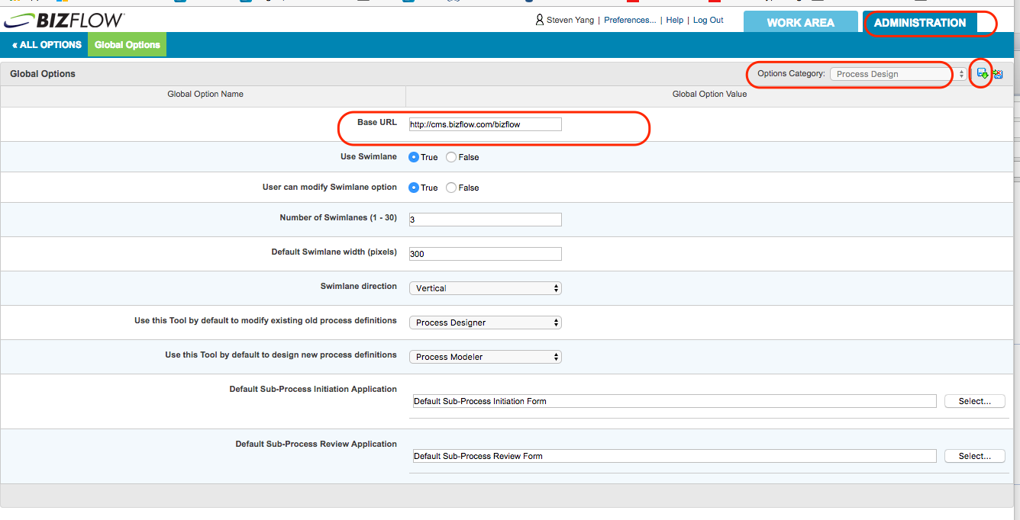

1. Select “Work Area Defaults” option for Options Category dropdown on the upper right corner.
2. Click disk icon next to the Options Category to check out.
3. Set “Current Process” option for Show Attachment dropdown.
4. Set “Current Process” option for Show Comments dropdown.
5. Click the disk icon with down arrow to check in the change.

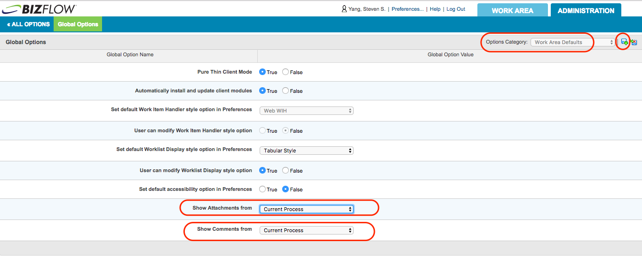

1. Log out of BizFlow Web Portal
2. Log in to the server machine which hosts BizFlow Server and BizFlow Web Application as a system administrator.
3. Open Services applet.
4. Restart all BizFlow related services and BizFlow Web Server (Tomcat) service.

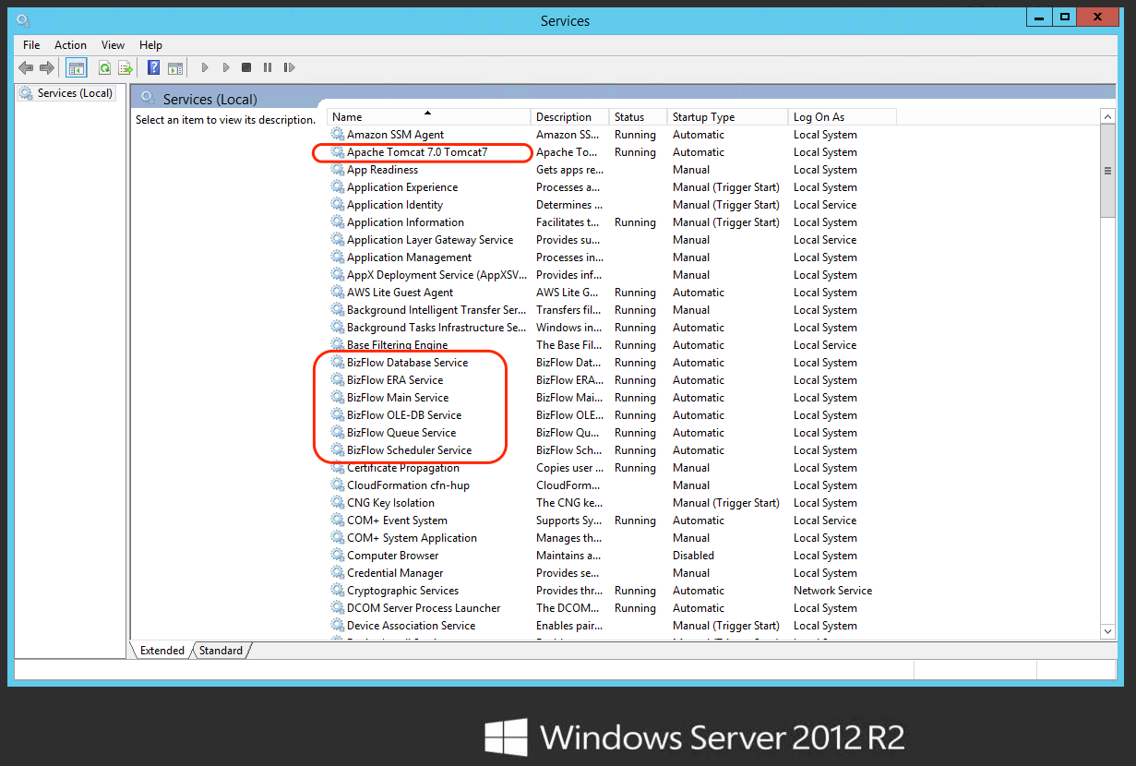

### 5.6.4 BizFlow Global Variable Configuration

After the first deployment of BIX file, the Global Variable should be configured for each environment. Any subsequent BIX import will not overwrite the value of the variable. The value must be set manually per environment. Currently, there is only one Global Variable.

* **usasPath** - USAS URL

In order to set the value, follow the steps below.

1. Open BizFlow Process Studio (BPS), and log in to the target server.
2. Open Operational Environment > Component Library from BizFlow Explorer pane, and select Global Variable.
3. In Content View, right-click on the variable, then choose Modify menu item.

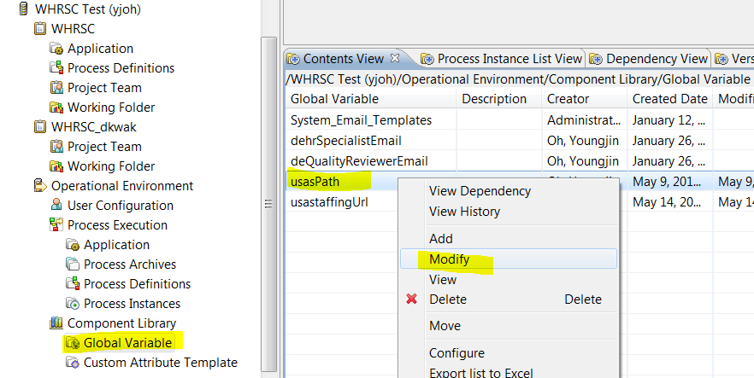

1. In Modify dialog, set the content of Value field as appropriate.

For example: /usasrwsc/usas/reportXML

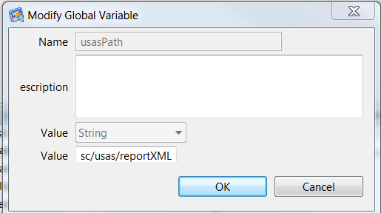

### 5.6.5 Internet Explore Configuration

If the user is using MicroSoft Internet Explorer to access BizFlow Web Portal, the following options must be set. The instruction below is for the individual users changing the option of their Internet Explorer. However, it is recommended that the HHS-wide system administrator (for Internet Explorer group policy) controls it centrally.

1. Open Internet Options menu in the Internet Explorer.

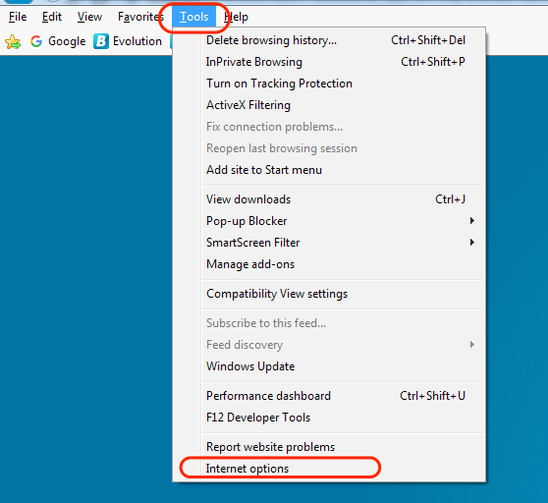

1. Click Security > Trusted Sites, then click Sites button.

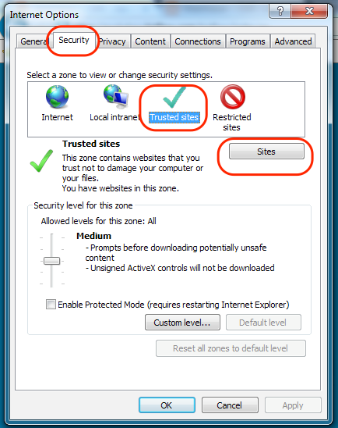

1. Set the Trusted Sites listing to include the HHS CMS BizFlow HR site URL.

For example, “http://dev.bizflow.hhs.gov/bizflow”

**Note**: If the site URL to be added is using http, not http**s**, you need to uncheck the “Require server verification (https:) …” checkbox before clicking “Add” button.

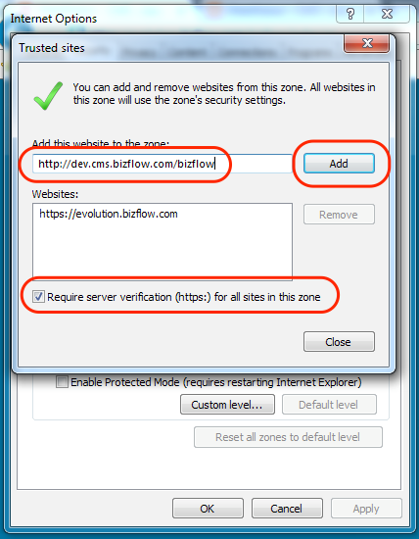

1. Close the open dialog boxes by clicking Close button, then OK button.

# Event Response Adaptor (ERA)

Create "Capital HR Initiation" ERA.

Pre-requisite: BizFlow user with “Designer”.

1. Log in to BizFlow Portal as a designer.
2. Click “ADMINISTRATION” tab on the top right corner.
3. Click "Event Response" on the administration page.
4. Click "Launch Event Response Designer Wizard" icon.

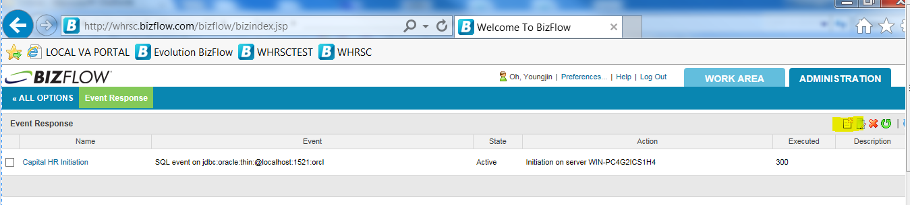

1. Step 1.
2. Select "SQL" for Event Type
3. Enter "Capital HR Initiation" on Name.

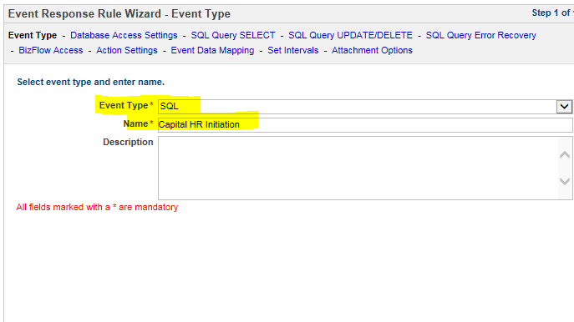

1. Step 2.
2. Provide JDBC driver Information : oracle.jdbc.driver.OracleDriver
3. Provide JDBC Database location URL.
4. Provide JDBC user name: BIZFLOW
5. Provide JDBC password.

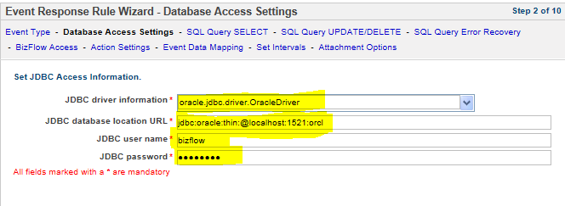

1. Step 3. Provide SQL Select query.

SELECT p.EFF_DATE,w.NAME as ORG_INITS, 'Branch ' || b.branch as BRANCH, e.* from HHS_WHRSC_HR.CHR_EMPLOYEE_INFO e

left join HHS_WHRSC_HR.CHR_PCA_INFO p on p.ID = e.ID

left join HHS_WHRSC_HR.CHR_WGI w on w.DEPT_ID = e.DEPT_ID

left join HHS_WHRSC_HR.BRANCHES b on b.IC = e.IC

where e.PROCESSED IS NULL

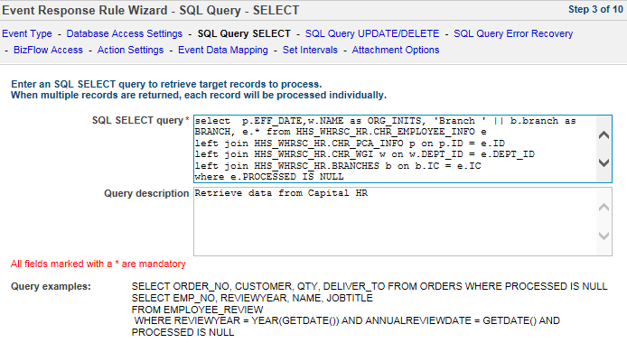

1. Step 4. Provide SQL Update/DELETE query.

UPDATE HHS_WHRSC_HR.CHR_EMPLOYEE_INFO SET PROCESSED = 'YES' WHERE ID = '${xpath:/records/record/ID}'

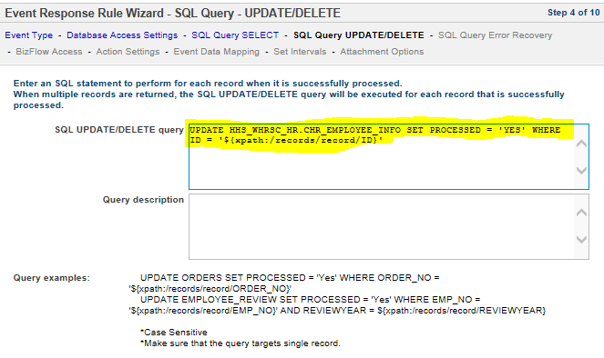

1. Step 5. Provide SQL error recovery statement.

UPDATE HHS_WHRSC_HR.CHR_EMPLOYEE_INFO SET PROCESSED = 'ERROR' WHERE ID = '${xpath:/records/record/ID}'

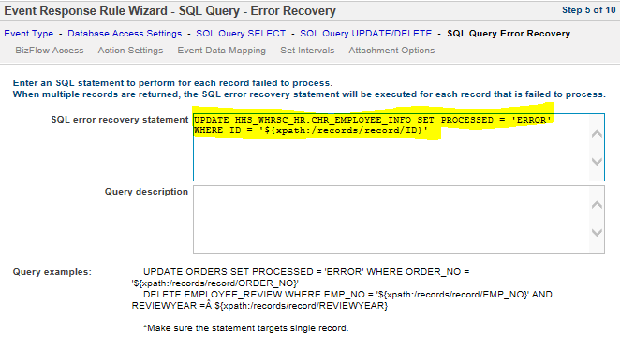

1. Step 6.
2. Provide Bizflow server name or IP.
3. Provide Bizflow port: Provide BizfFlow port, for example, 7201
4. Provide Bizflow ERA user ID.
5. Provide Bizflow ERA password.

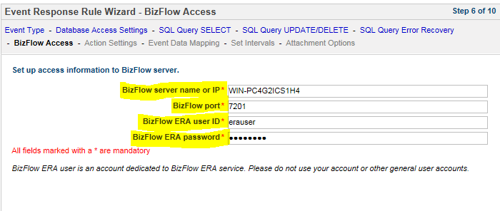

1. Step 7. Click "Select" button on Process Initiation. And then select process Definition "Determine Staffing Process"

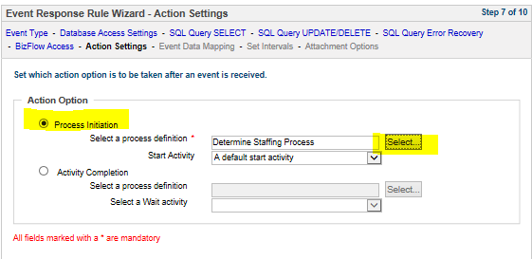

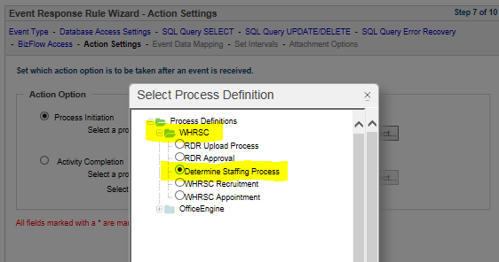

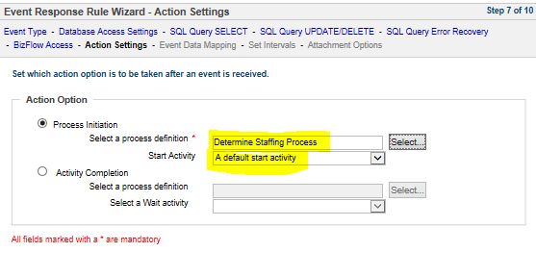

1. Step 8. Select one item from Columns list box and one item from Process Variable list box. Use Add arrow button to move mapped items to Mapped Items list box.
2. BRANCH - originalBranch
3. BRANCH - branch
4. ORG_INITS - orgInit
5. OCC_SERIES - requestedSeries
6. JOB_TITLE - requestedPositionTitle
7. PAY_PLAN - requestedPayPlan
8. GRADE - requestedGrade
9. EFF_DATE - proposedEffDate
10. DATE_ADDED - dateEntered
11. DEPT_ID - adminCode
12. IC - customerCenter
13. ID - requisitionNumber

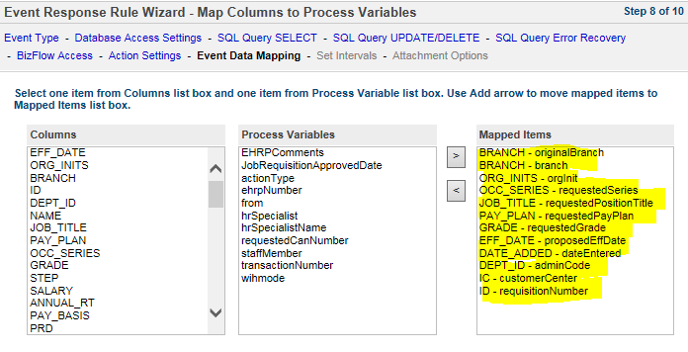

1. Step 9. Set Interval period to "15" minutes.

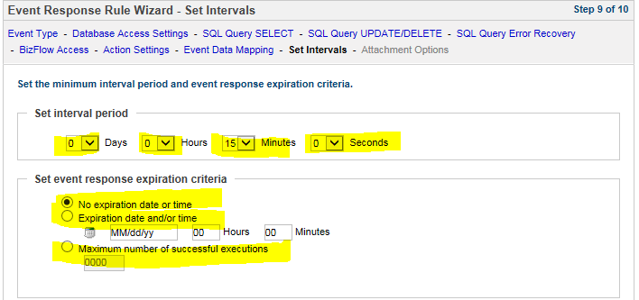

1. Final Step. Click "FInish" button.

About Deloitte

Deloitte provides audit, tax, consulting, and financial advisory services to public and private clients spanning multiple industries. With a globally connected network of member firms in 140 countries, Deloitte brings world-class capabilities and deep local expertise to help clients succeed wherever they operate. Deloitte's 165,000 professionals are committed to becoming the standard of excellence.

Deloitte's professionals are unified by a collaborative culture that fosters integrity, outstanding value to markets and clients, commitment to each other, and strength from cultural diversity. They enjoy an environment of continuous learning, challenging experiences, and enriching career opportunities. Deloitte's professionals are dedicated to strengthening corporate responsibility, building public trust, and making a positive impact in their communities.

Deloitte refers to one or more of Deloitte Touche Tohmatsu, a Swiss Verein, and its network of member firms, each of which is a legally separate and independent entity. Please see www.deloitte.com/about for a detailed description of the legal structure of Deloitte Touche Tohmatsu and its member firms. Please see <http://www.deloitte.com/us/about> for a detailed description of the legal structure of Deloitte LLP and its subsidiaries.

Internal Usage Statement

This publication is for internal distribution and use only among personnel of Deloitte Touche Tohmatsu, its member firms, and its and their affiliates. Deloitte Touche Tohmatsu, its member firms, and its and their affiliates shall not be responsible for any loss whatsoever sustained by any person who relies on this publication.

Copyright © 2012 Deloitte Development LLC. All rights reserved.

Member of Deloitte Touche Tohmatsu